<https://learn.microsoft.com/en-us/aspnet/core/web-api/advanced/formatting?view=aspnetcore-8.0>

builder.Services.AddControllers()

.AddXmlSerializerFormatters();

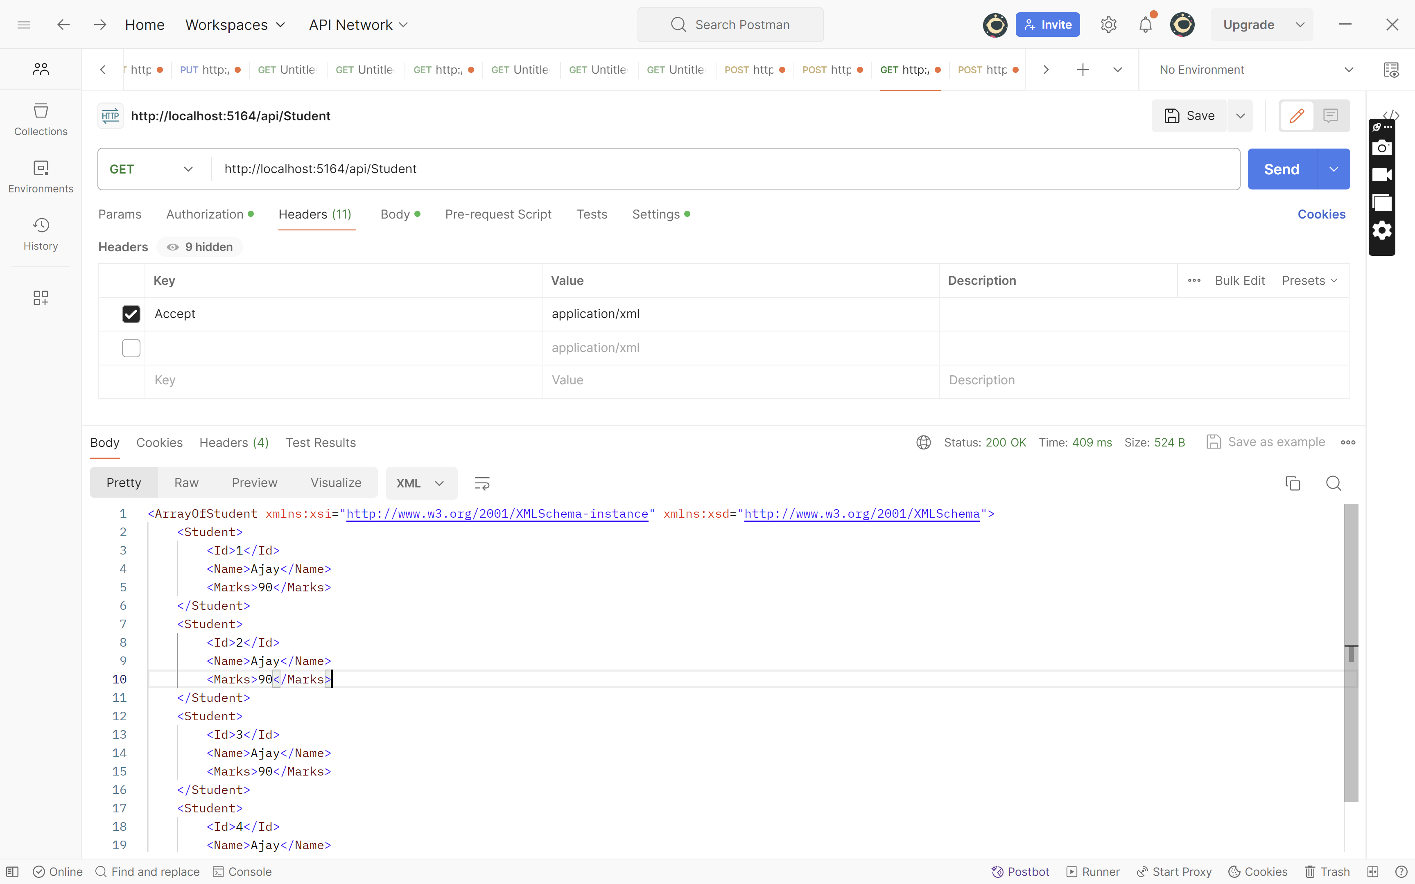

To throw Exception when some format is not supported

builder.Services.AddControllers(options=>options.ReturnHttpNotAcceptable=true);

<https://www.aspsnippets.com/questions/142078/Return-XML-response-from-Web-API-in-ASPNet-Core-MVC/>